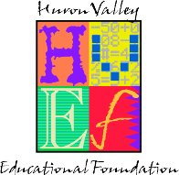
HURON VALLEY EDUCATIONAL FOUNDATION
Reflection

Mission Statement: We will create an impact on education in the Huron Valley community by: providing greater opportunities to enhance learning experiences; generating and distributing financial resources to benefit citizens in the Huron Valley community; and collaborating with like-minded organizations.

Grant Reflection is due by the end of the school year.

Name:
School:
Project Name:

Did this project meet your expectations; what worked; what would you do differently; should/could this be replicated?

